EXPERIMENT 2: AVERAGE PRICE OF PRODUCTS SOLD

AIM
To calculate the average value of the given product sales-price data using NumPy.

ALGORITHM
- Import the NumPy library.
- Create a 3 × 3 array containing the price values for three products.
- Calculate the average of all values using np.mean().
- Display the average value.

PROGRAM / CODE
import numpy as np
sales_data = np.array([
[100, 200, 300],
[150, 250, 350],
[200, 300, 400]
])
average = np.mean(sales_data)
print("Average price of all products:", average)

INPUT
Sales-price data (3 × 3 matrix):
[[100, 200, 300],
[150, 250, 350],
[200, 300, 400]]

OUTPUT
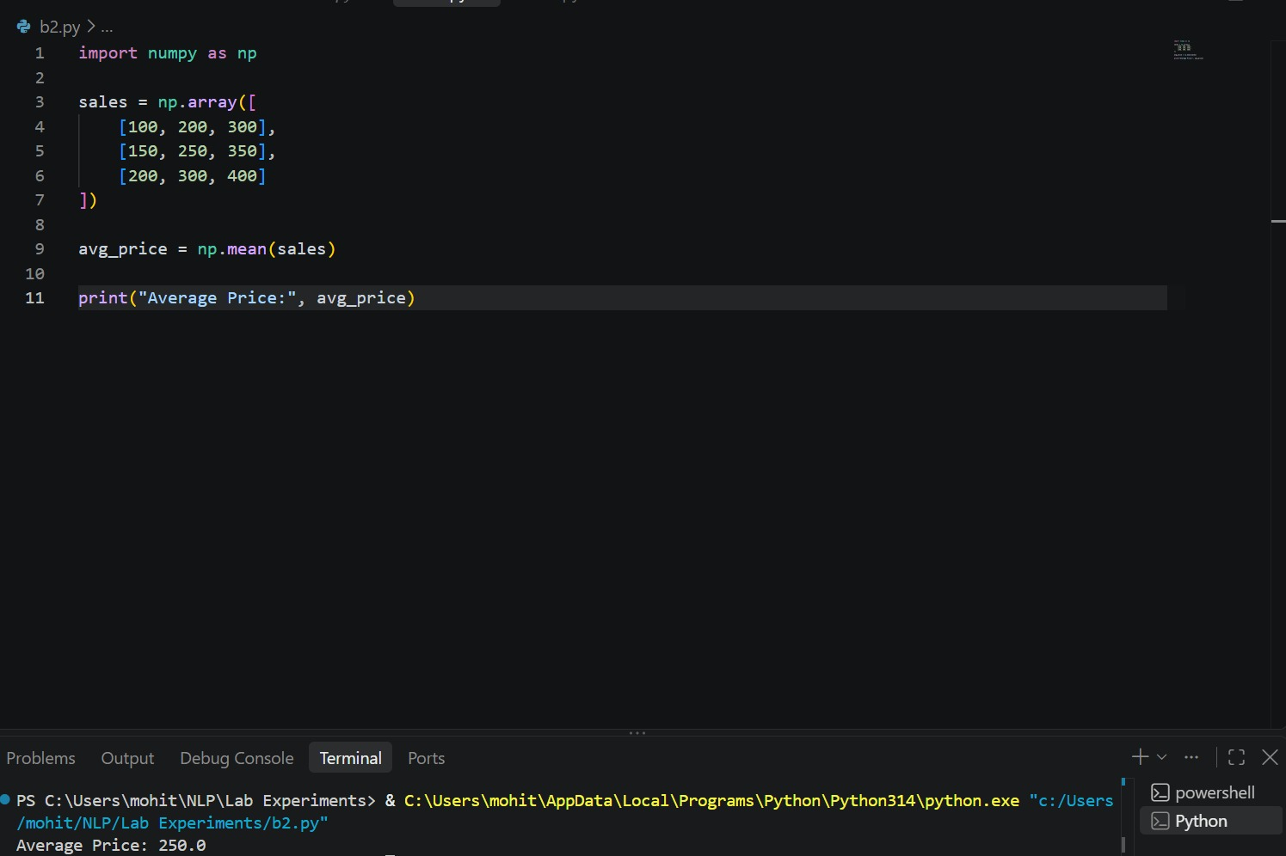
Average price of all products: 250.0

RESULT
The program calculates the average of all the given values as 250.0. This assumes the array contains product prices.

